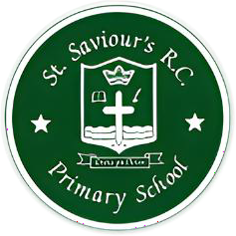

St Saviour’s RC Primary School
Pray Together, Learn Together, Stronger Together in Jesus

St Saviour’s Staff List 2026/27

Senior Leadership Team Office Staff
Headteacher Mrs Onye
Assistant Head/SENCO Miss Tavernier Senior Admin/Parent Liaison Officer Miss Kahlon School Business Manager Miss Reid Administrative Officer Mrs Hodges Premises Manager Mr Stopperton

Teachers Teaching Assistants
Reception Ariane Ghafour Ibrahim Nursery Nurse Lisa Holme
Chenique Hunter- Anderson

Year 1 Brydie Gregory Year 1 Josie Dummett

Year 2 Manuela De Rogatis Year 2 Christina Appassamy

Year 3 Jessy Jacob Year 3 Chanell Segbefia

Year 4 Abraham Kallon Year 4 Jill Burrell
Michael Mohammed
Mikale Bolton

Year 5 Donna Malumbe Year 5 Geraldine O’Toole

Year 6 Japo Okworobu Year 6 Anupamaa Bhurrut

SEN Support Ewa Wawak
Mimi Basele

Music Teacher and PPA Cover Julie Wood Midday Meal Supervisor/ASC Shafi Begum Midday Meal TA Valerie Forbes

PE Coach/PPA Cover
Kieron Allen-Roper

